Unit Four: Head and Face

Fall Semester Final Study Guide

1. Know skeletal and soft tissue anatomy
   1. Label the pictures

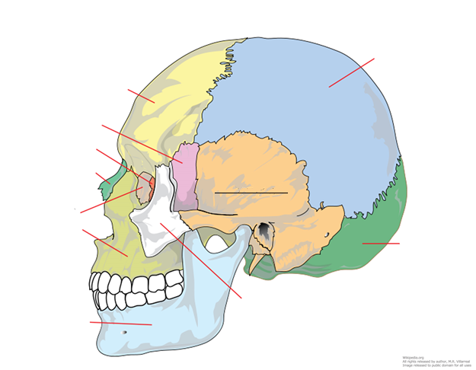

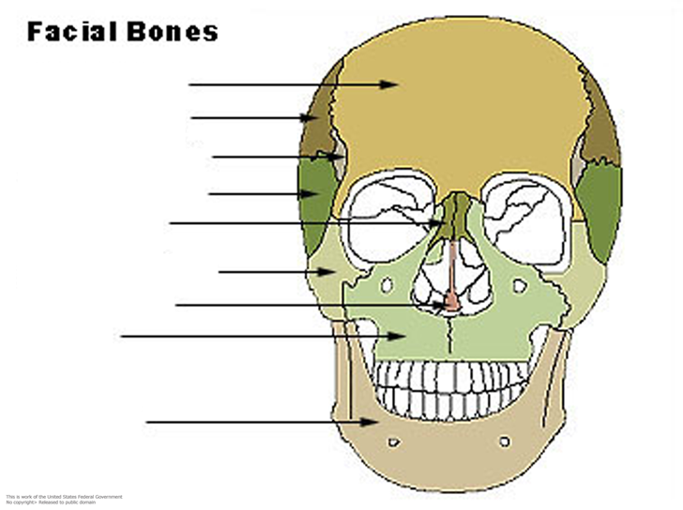

* 1. What are the layers of the brain? What is the difference between a sub- & epidural hematoma?

1. What are the 12 cranial nerves and what do they control?
2. Know the eye injuries (MOI, S&S, TX) Understand the similarities & differences between each!
3. Know the ear, nose and mouth injuries (MOI, S&S, TX)
4. What does SOAP mean? Describe the information that belongs in each section of a SOAP Note.
5. How can you get a concussion or TBI?
6. What are the S&S of a TBI?
7. How do you care for a TBI?
8. Why are concussions & TBI more prominent in medicine lately?
9. Describe how concussions are accurately diagnosed. What are the issues with using imaging (CT, MRI/fMRI)?